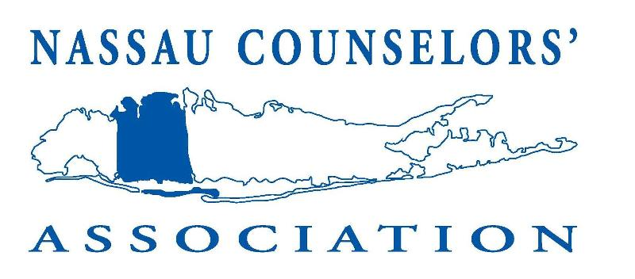
NCA’S KICK-OFF MEETING

Thursday, October 24, 2024
3:30pm – 7:00pm

Proudly sponsored by



Please join us for a presentation on
“THE POWER OF ARTIFICIAL INTELLIGENCE IN EDUCATION”
Patrizia’s Restaurant
4913 Merrick Rd.
Massapequa Park, NY 11762

$15 members
$45 non-members (includes membership fee)*
*Please include a membership application with your response
Kindly make checks payable to NCA

Please RSVP by Thursday, October 17th
*There is no on-site registration available*
Please tear off the bottom portion of this flyer and return to:
Marguerite Lane
Associate Vice President for Enrollment Management
Molloy University
1000 Hempstead Avenue
Rockville Centre, NY 11570

Please remember to include your check
-------------------------------------------------------------------------------------------------------------------------
Name__________________________________ Title______________________________
School_____________________________________________________________________
Email Address_______________________________________________________________
Telephone #________________________________ Are you a member of NCA? Yes No

