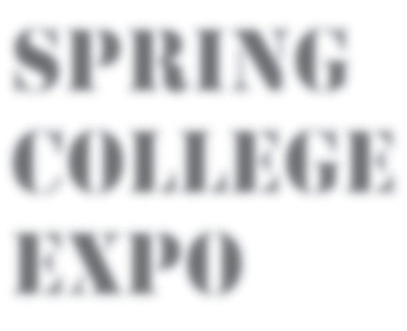
Dear Colleague,

Each year as your professional organization, the NASSAU COUNSELORS’ ASSOCIATION provides an outstanding resource to benefit students and parents at our Spring College Expo. This event brings over 300 colleges, university, and post high school program representatives from around the United States to our backyard.

The Spring College Expo offers:
- One-to-one conversations with school and program representatives
- Experienced counselors to assist in the search process
- Valuable seminars and information tables explaining concepts such as financial aid, the college admissions process, NCAA, students with special needs, and historically black colleges and universities.

With this letter, you will find a “Save the Date” publication detailing this wonderful event. We ask that you kindly duplicate this informative handout and display it in your office, on your school website, through your school wide e-mail system, and disseminate to your students and parents in individual meetings or any other creative way that you deem effective in your school! We will also e-mail you the PDF file of our “Save the Date” and post it on the “Spring College Expo” section of the NCA website to allow for easier reproduction! Additional promotional material will be sent in the upcoming weeks.

**PRIOR TO THE EVENT, students are strongly encouraged to register and receive a barcode at gotocollegefairs.com. This barcode can be scanned from any smart phone and will greatly enhance their expo experience!

Your assistance in promoting and utilizing this amazing opportunity for students and parents is GREATLY appreciated. Please check our website at www.nassaucounselors.org for the most updated information

We look forward to seeing you and your students
Tuesday, April 25th 2017, 5:30-8:30PM
MACK SPORTS AND EXHIBITION COMPLEX
Hofstra University

Sincerely the NCA Spring Expo Co- Chairs,

Jaclyn Forman Sunil Samuel
School Counselor Assistant Vice President of Admission
Harborfields High School Hofstra University
Jaclyn.forman@gmail.com Sunil.a.samuel@hofstra.edu

It’s time to jumpstart your future.

46TH Annual

Sponsored by the Nassau Counselors’ Association

Meet personally with representatives from over 300 colleges, universities, career schools and military services at the spacious, conveniently located

MACK SPORTS AND EXHIBITION COMPLEX
Hofstra University
245 Hofstra Blvd, Hempstead, NY 11549

TUESDAY, APRIL 25th 2017, 5:30-8:30PM
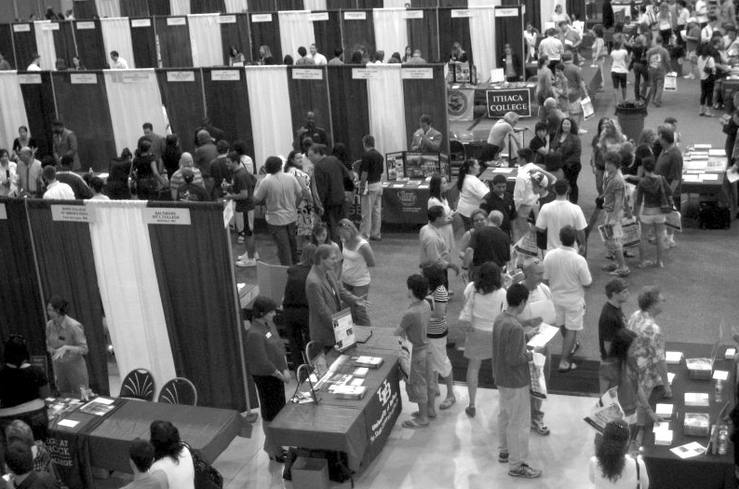

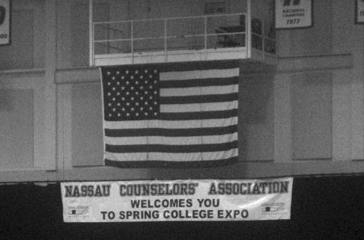

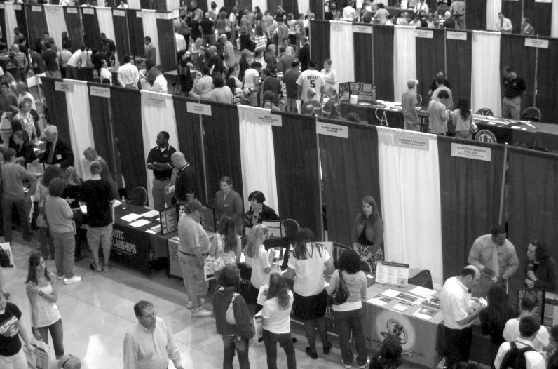

In addition to speaking with school representatives, you will have an opportunity to attend these valuable workshops:
FINANCIAL AID • COLLEGE ADMISSIONS • STUDENTS WITH SPECIAL NEEDS STUDENT ATHLETES & THE NCAA • THE COLLEGE APPLICATION PROCESS
PROFESSIONAL COUNSELORS WILL BE AVAILABLE TO PROVIDE COLLEGE SEARCH ASSISTANCE

*Remember to register for your individual barcode at gotocollegefairs.com to make your visit to the fair more productive!
Visit www.nassaucounselors.org for additional information.

This event is offered as a FREE public service.

Detailed information about schools attending, specific workshop times & travel directions will appear in EXPO booklets, available from your counselor in April, as well as on our website!

